Nama : Yoga Aditama

NIM : 1900018009

PWD Kegiatan 7 Rabu 07.30

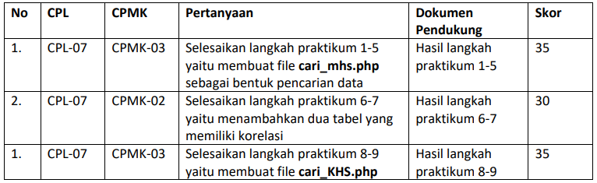

1. Cari_mhs.php

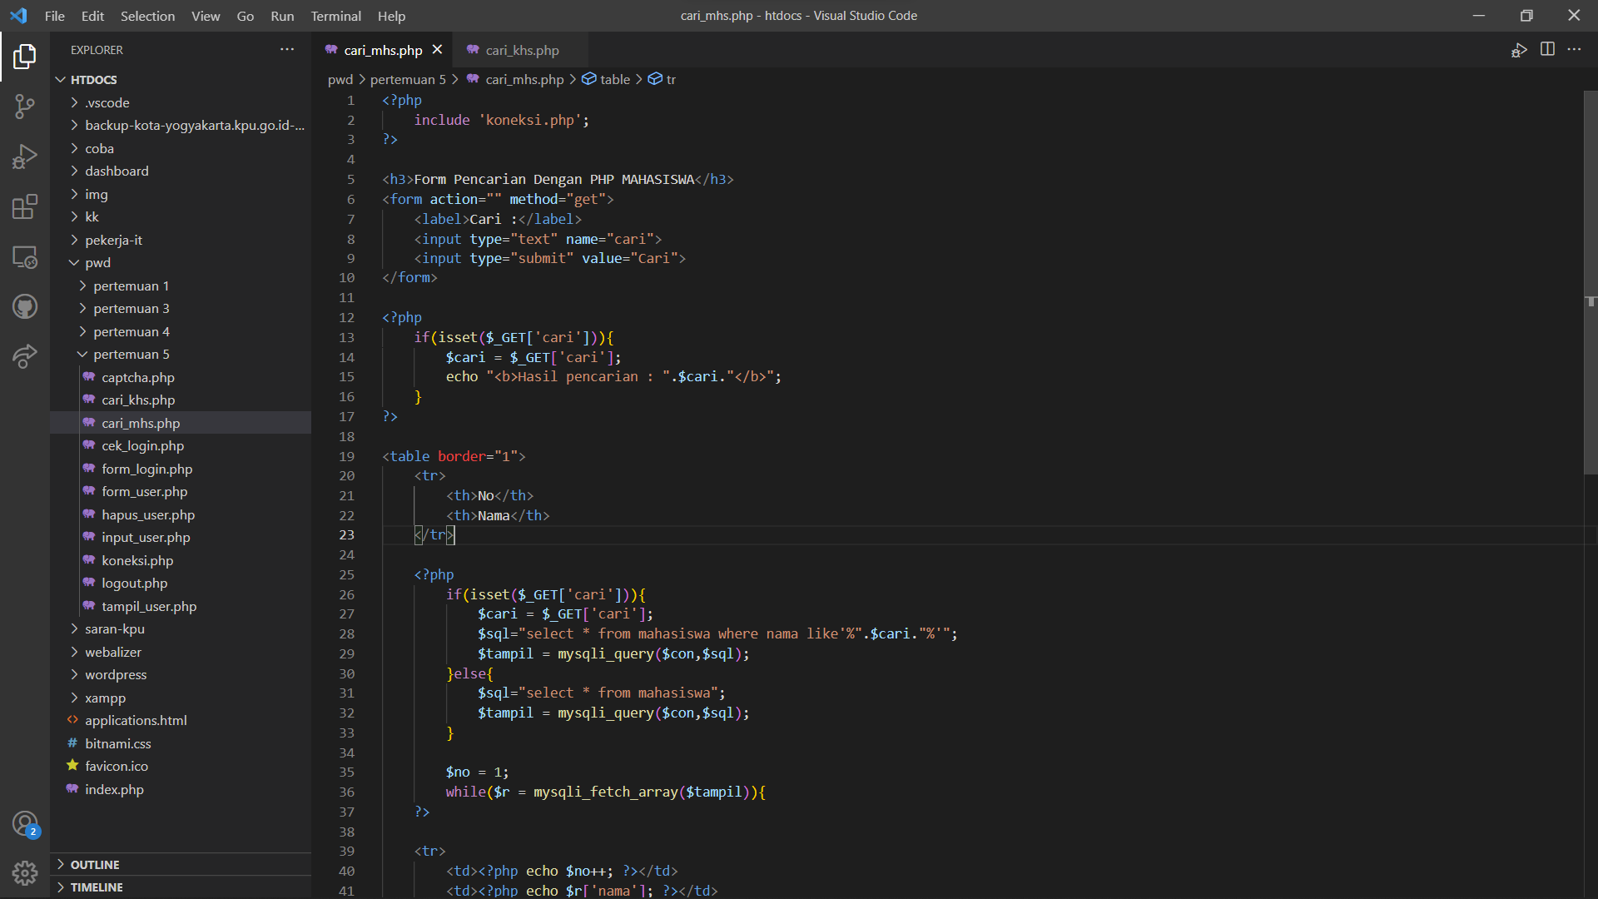

1. Mata kuliah

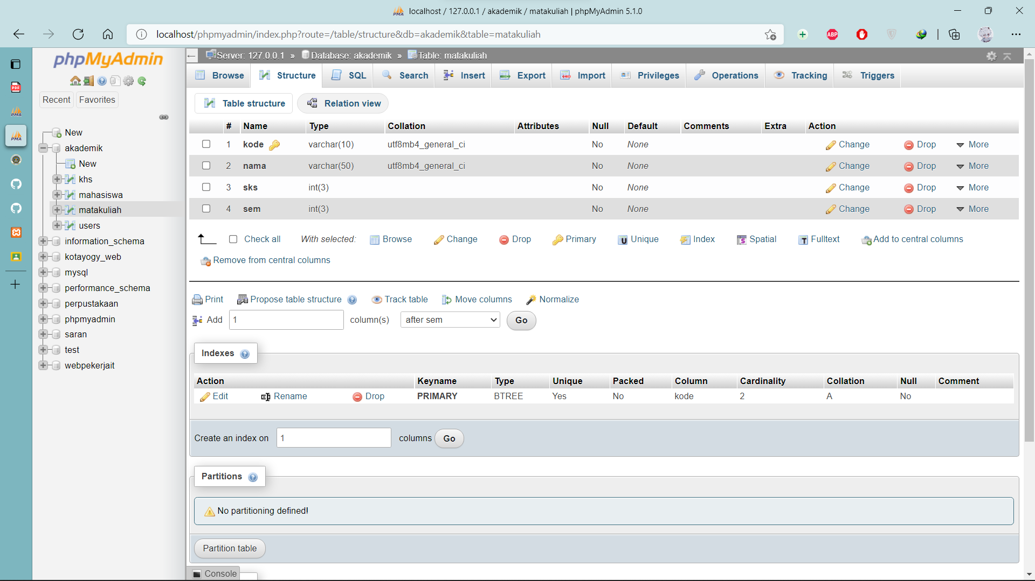

KHS

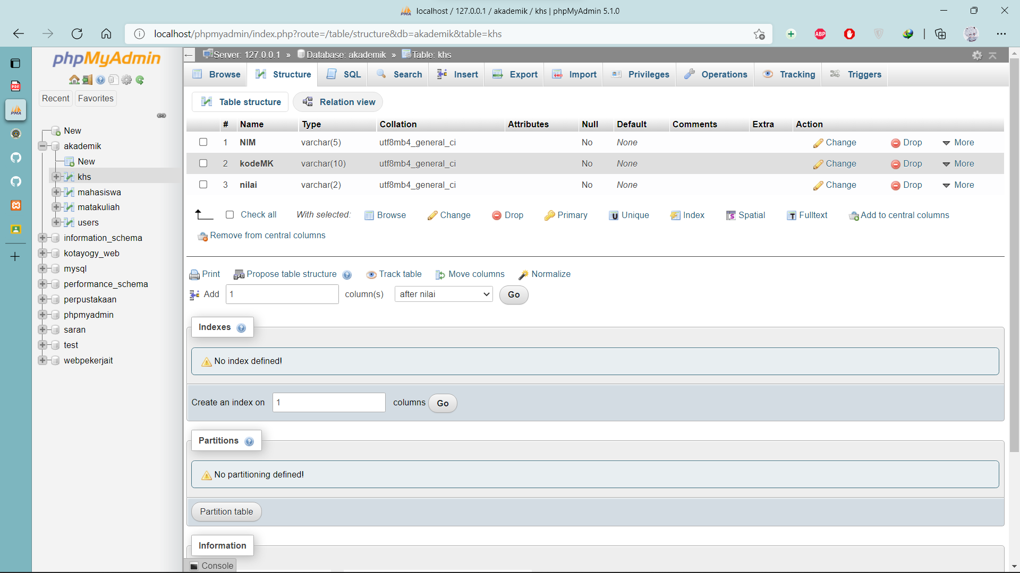

1. Cari_khs.php

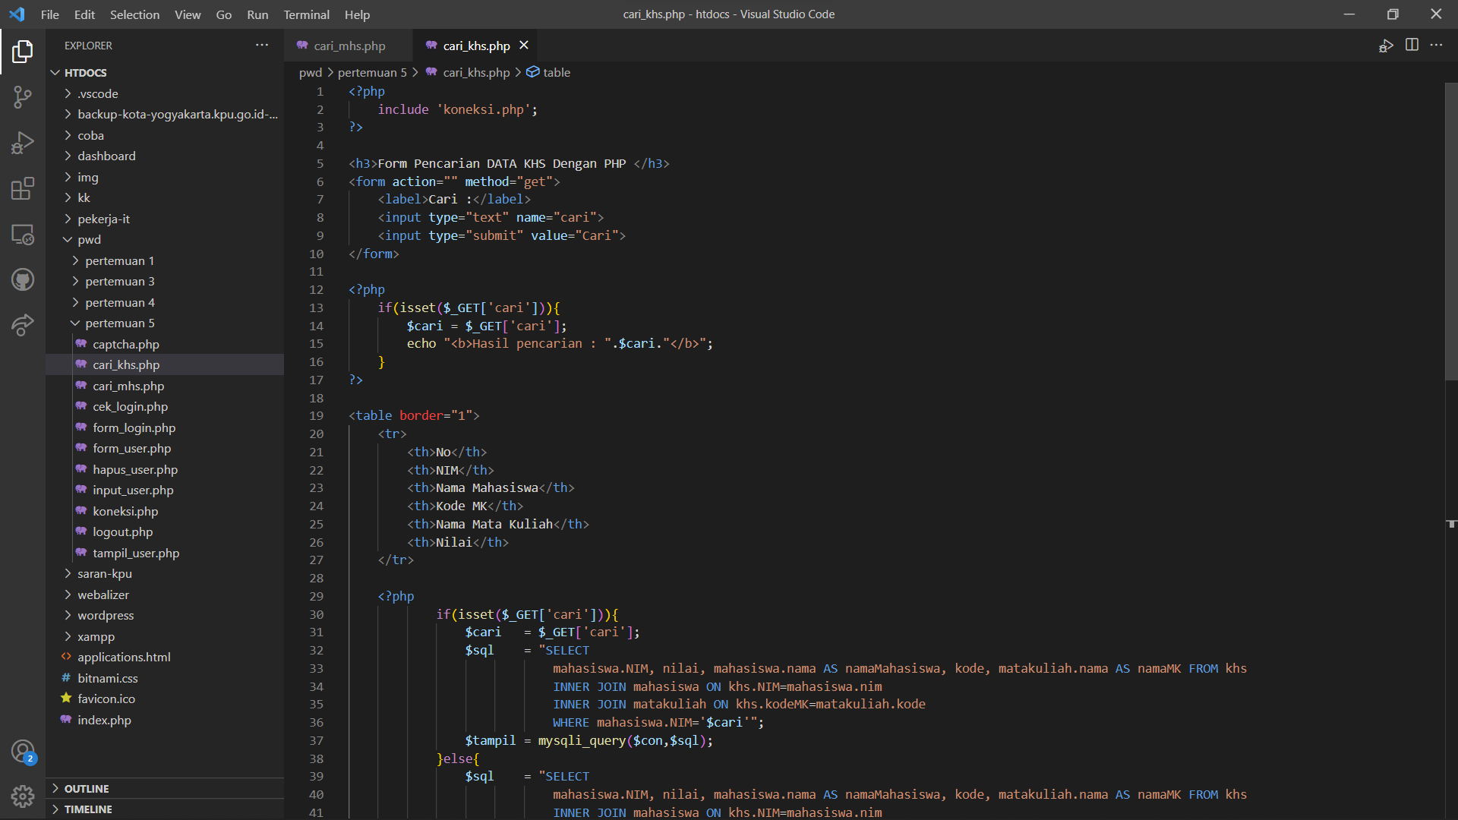

Hasil runningan

**Cari_mhs.php**

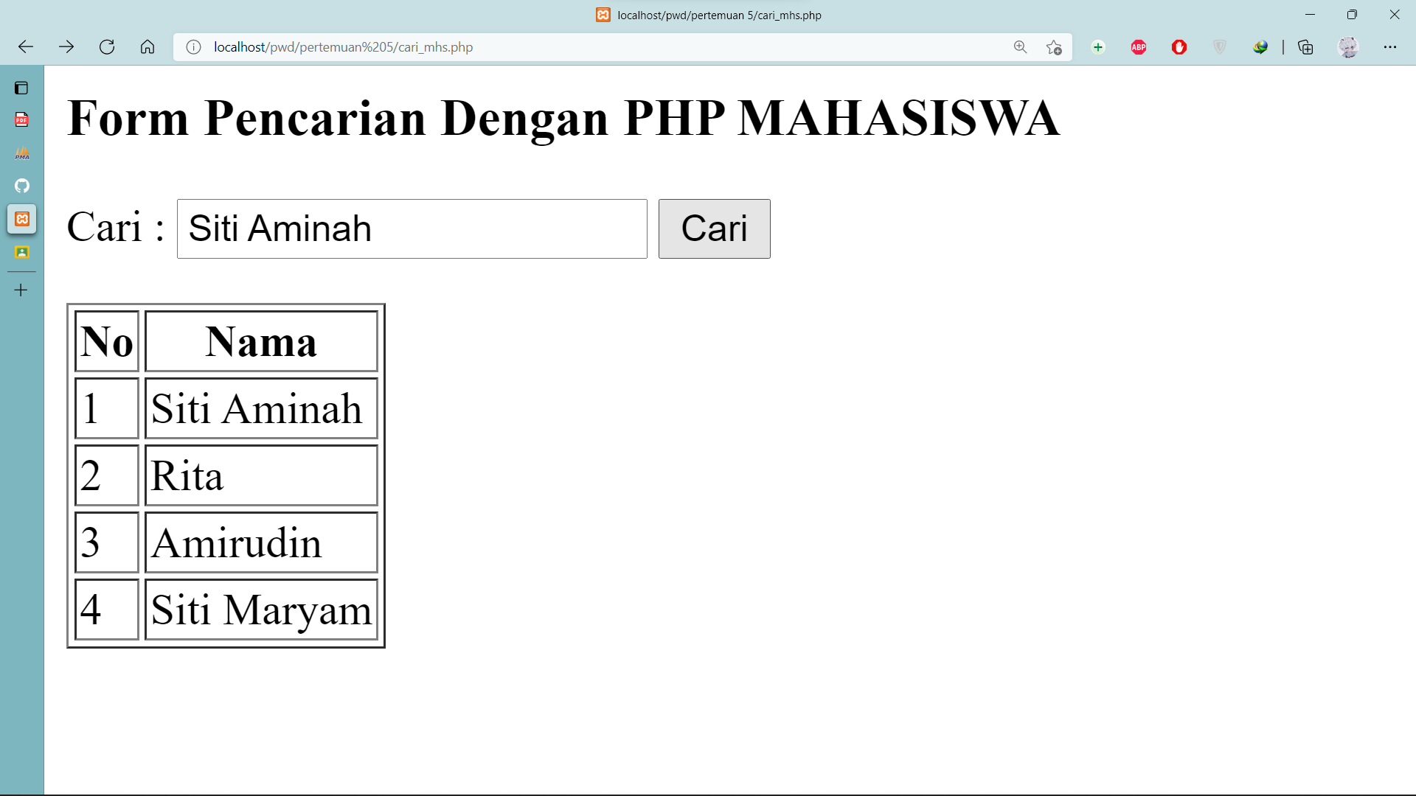

Hasil pencarian

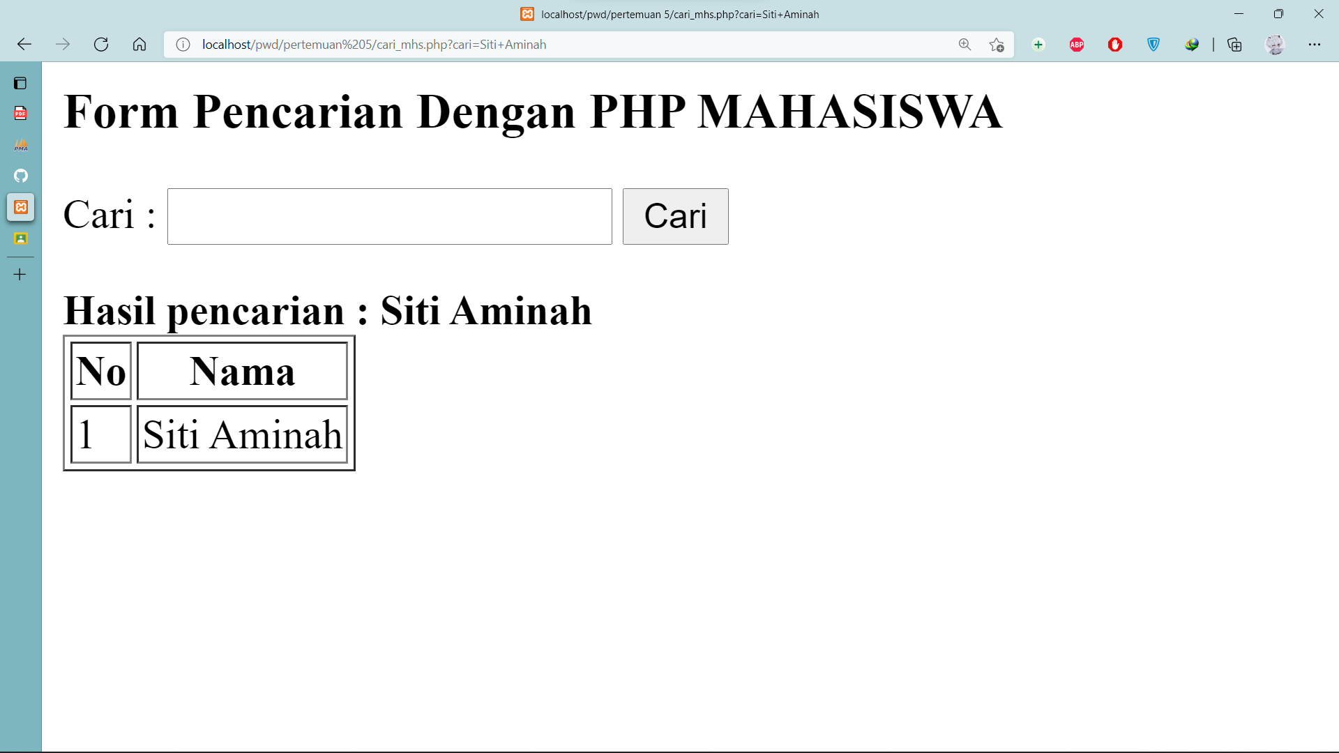

**Cari_khs.php**

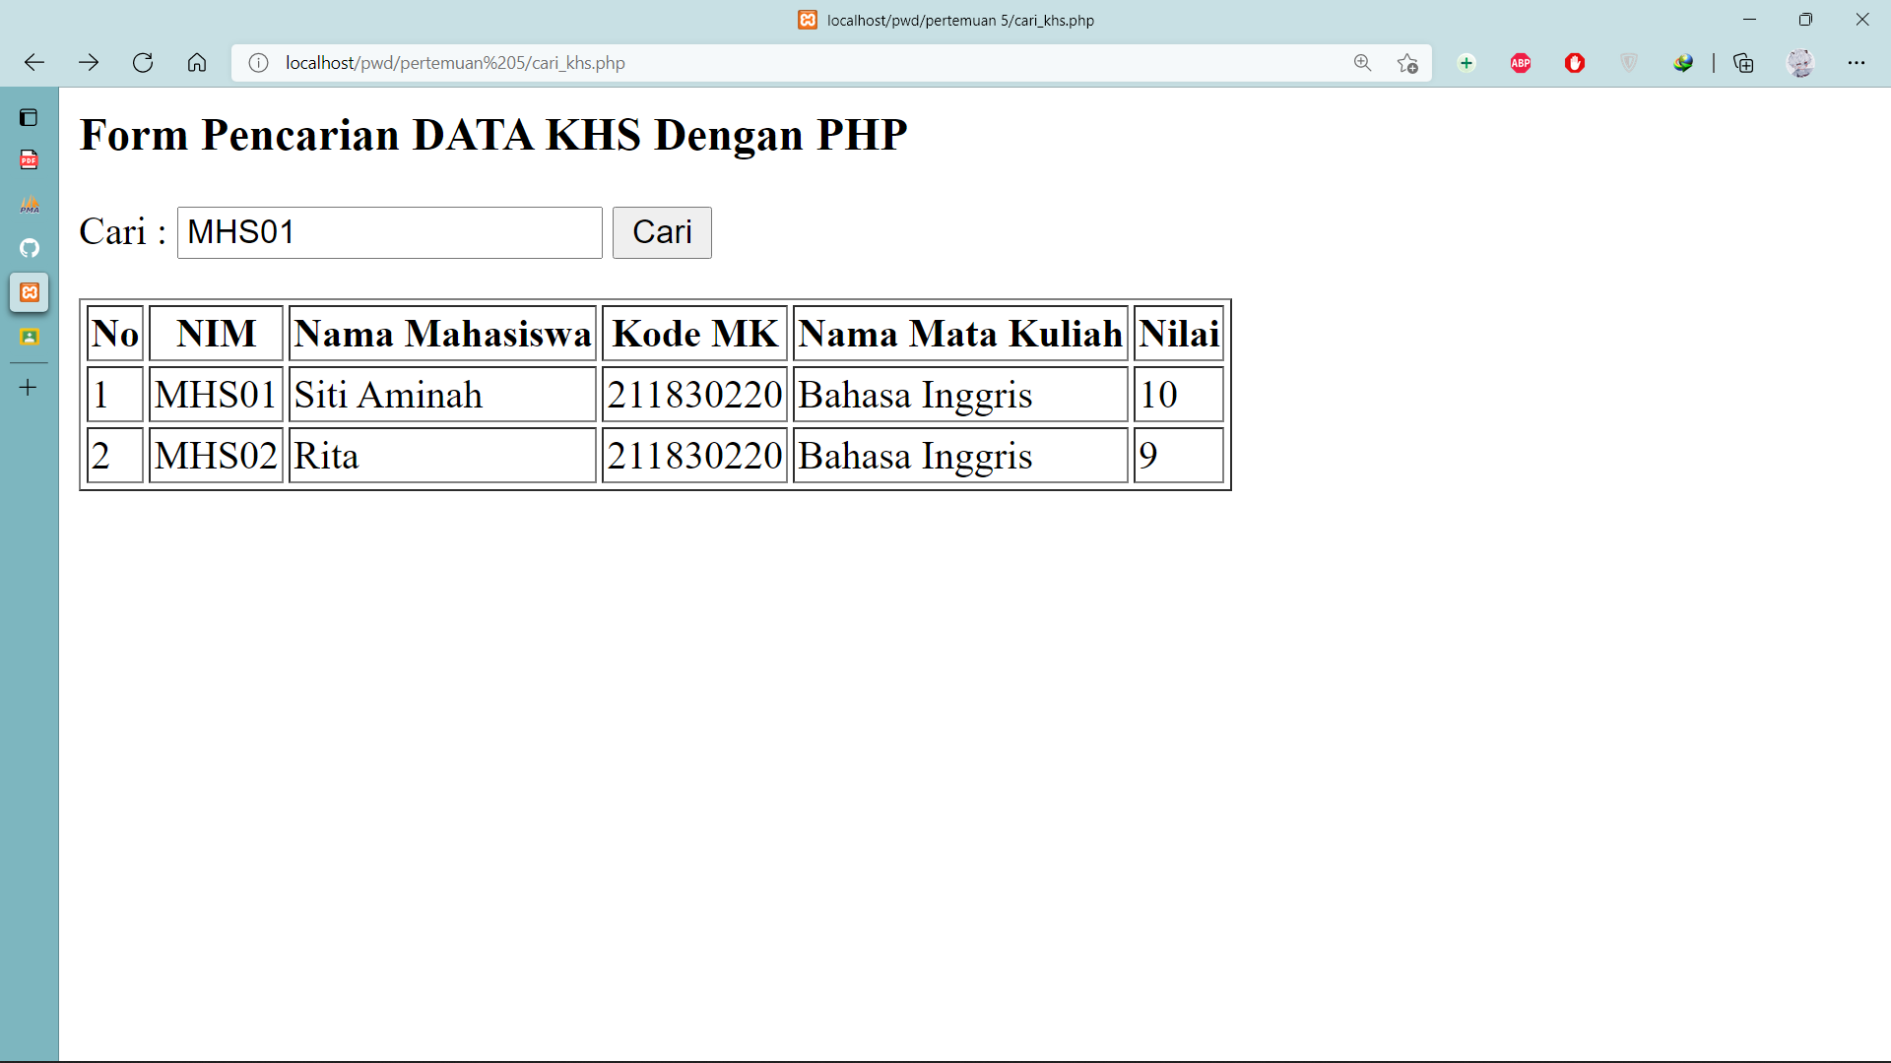

Hasil pencarian

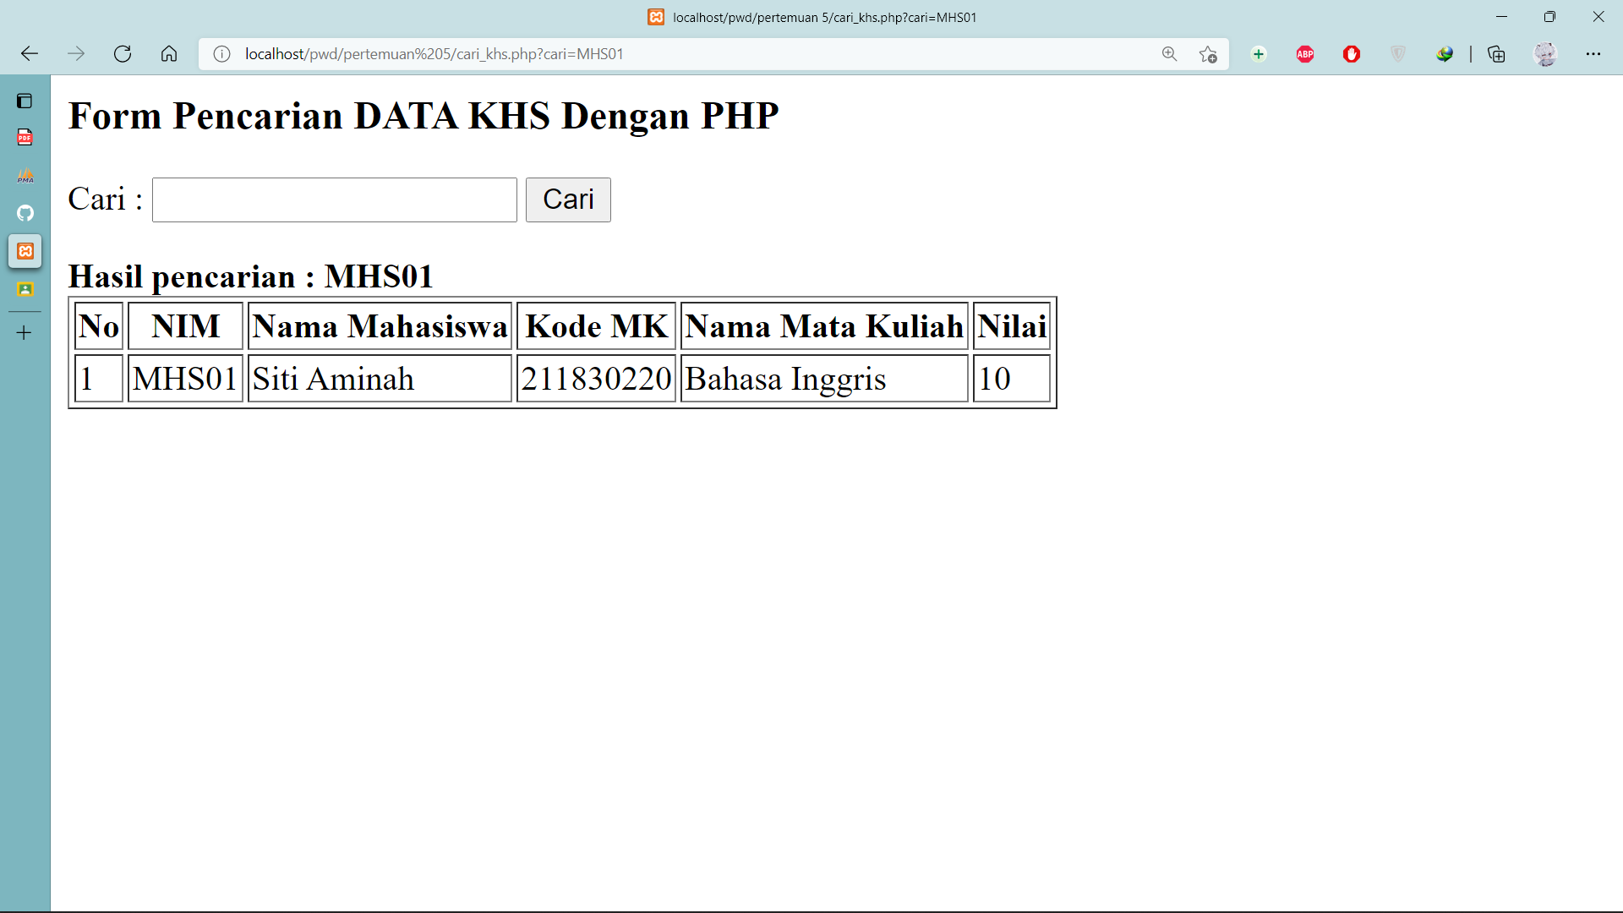

Github [yogaaditamaa/PrakPWD (github.com)](https://github.com/yogaaditamaa/PrakPWD)